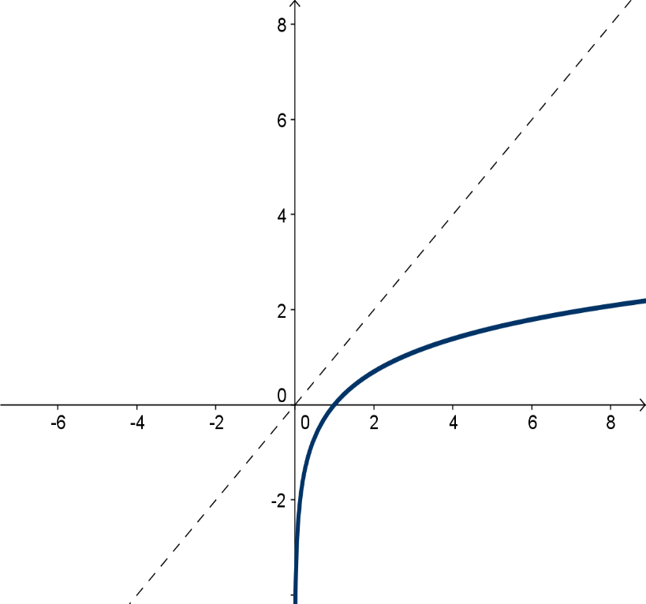
$G_{f}=\left\{\left(x,y\right)\left|x∈A,y∈\right.B,y=f(x)\right\}$$${ G}_{f^{-1}}=\left\{\left(x,y\right)\left|x∈B,y∈\right.A,y=f^{-1}(x)\right\}$$${ G}_{f^{-1}}=\left\{\left(x,y\right)\left|x∈B,y∈\right.A,x=f(y)\right\}$
